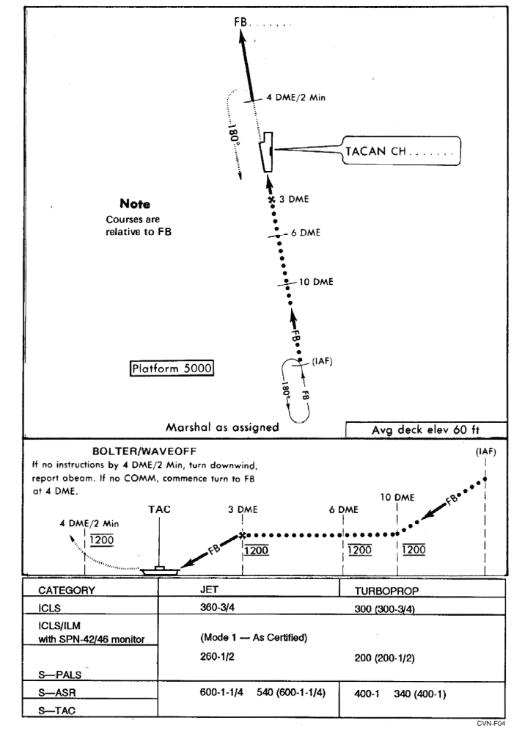
Approach Chart CV-1 TACAN (Jet and Turboprop)

